

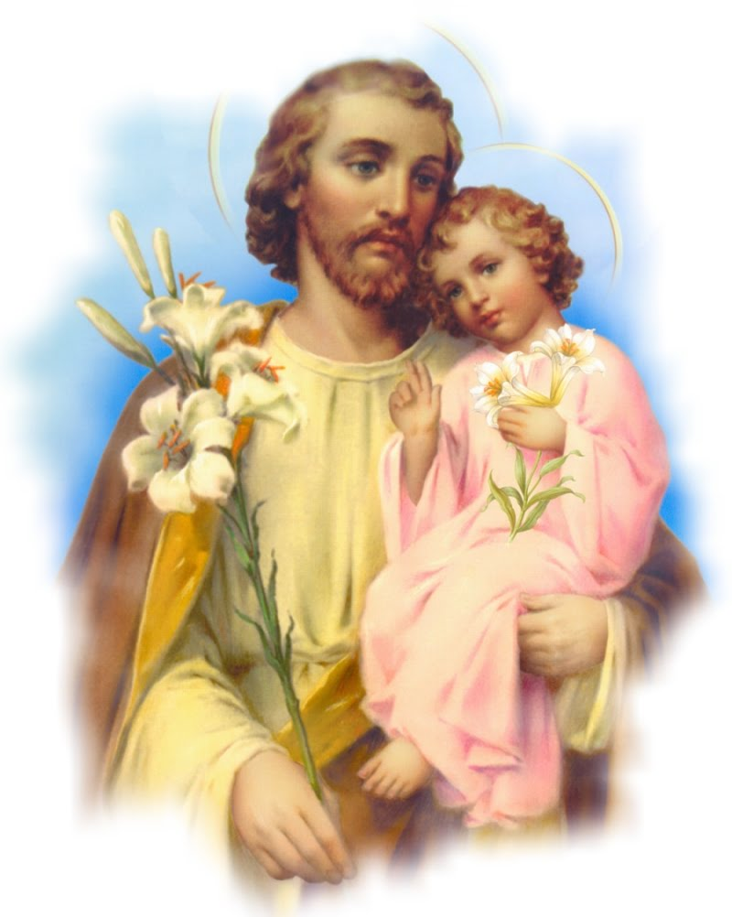
STRATEGIC PLAN

A tool of evolution for the St. Joseph’s Hospital, Jirapa
Upper West Region
2023-2028

THE ST. JOSEPH’S HOSPITAL

Contents
CHAPTER 1 4
Introduction, Background And Historical Development 4
History of St. Joseph’s Hospital 4
Key Demographics of the District 5
Compliment and catchment area of the hospital 6
Map of Jirapa District 7
Rationale And motivation for A strategic development plan 7
CHAPTER TWO 8
Vision 8
Mission 8
Operationalization of Mission and Vision 8
Broad policies ………………………………………………………………………………………………………………………………8
Services available 8
Core values. 9
Existing Stakeholders 9
Stakeholder Involvement 10
Stakeholder Analysis 10
Swot Analysis 11
Key Issues. 12
Human Resource 12
Logistic 13
Infrastructure 13
Finance 14
CHAPTER THREE 15
Implementation Plan Human Resource 15
Logistic 15
Strategic Goal- Availability Of Basic Logistics For All Departments. 15
Infrastructure 16
Finance 16
CHAPTER FOUR 17
Organizational Structure 17
The Executive Board 17
The Management Team 17
Functions of the Management Team Members 19
Decision Making by the Management Team 19
Core Management Team Members 19
Core Management Team Members 20
CHAPTER SIX 21
Framework From Programmes To Activities, 2017-2022 21
Budget of Activities 24
CHAPTER SEVEN 29
Staff Strength 29
Hospital Bed Occupancy 30

CHAPTER 1

Introduction, Background and Historical Development
Stock taking of the past decades, revealed that many local Churches in Ghana have been deeply concerned about the level of access of the majority of the population especially those at the periphery, to basic amenities, facilities and necessities of life. This runs from safe drinking water, good sanitation and health to education and food production for household consumption. In line with this mission, many of the Churches have adopted policies and programs aimed at improving the living conditions and livelihood chances of especially the vulnerable rural poor, the marginalized and the deprived.
Consequently, and as health is a nation’s wealth, most of the Christian Churches have substantially expanded their collaborative efforts in the fields of health service delivery aimed at the poor. Though the local Churches have nominally come of age, they still need a lot of sustained support and strategic partnerships to bring to fruition their mandate, mission and vision in integral human development and renewed evangelization Structures, systems, infrastructure, capacity building and development, advocacy and lobbying, networking and collaborative efforts have to be stepped up and sustained for effective and efficient performance.

History of St. Joseph’s Hospital
St. Joseph’s Hospital was started in the convent of the Franciscan Missionaries of Mary Congregation (FMM) in 1949 as a wound dressing centre for the people of Jirapa and its surrounding communities. In 1953, the then Catholic Mission of Tamale adopted and converted the wound dressing centre into a hospital to provide basic services in General Medicine, Deliveries, Surgery and child health care; with the sole aim of extending the healing ministry of Christ to the poor and marginalized. Aside the clinical service, the Hospital was also mandated to train pupil nurses and midwives to the required standards of the regulatory bodies (Ministry of Health).
It was also moved to its present site and managed solely and purely as a mission institution by the Church. Their critical staffs were mainly expatriates.
In 1956, the Mission entered into an Agency Agreement with the government of the then Gold Coast, now Ghana, where the government was required to provide such infrastructure, as may be required, and the emoluments of the requisite staff engaged and employed by the Mission. The Agency Agreement in its original form has remained till date, but its operations have substantially changed over the period. The training schools have assumed autonomy and the mode of engagement and employment of some key staff has altered.
The facility serves as the only Hospital in the Jirapa Municipal with a catchment population of 91,279, from 2021 census. This population is spread over seven (7) sub-districts and fourteen (28) active Community Health and Planning Services (CHIPS) zones. The population is mostly made up of two main ethnic groups, the Dagaabas and Sissalas and some few Fulani herdsmen.
The main objective of the hospital is to extend the healing ministry of Christ to all, irrespective of race, creed, colour or gender, and based on Christian ethics and principles.
The specific objective of the hospital is to deliver accessible and quality healthcare services in a congenial atmosphere, to the optimum satisfaction of our clients through a well-motivated staff.

Key Demographics of the Municipal
According to the 2021 Population and Housing Census, the estimated population of the Jirapa Municipal is 91,279; consisting of 43,021 males (47%) and 48,258 females (53%). With a land size of 1,188.6 Km sq the population density stands at 76.61 persons/sq km. Consequently, there has being an increasing pressure on land and other existing social amenities like the district hospital, water facilities among others. The sex composition of the population requires that a concerted effort should be made at involving women at all levels of decision-making and for that matter the need to make adequate provision for the education of the girl.

MAP OF UPPER WEST REGION
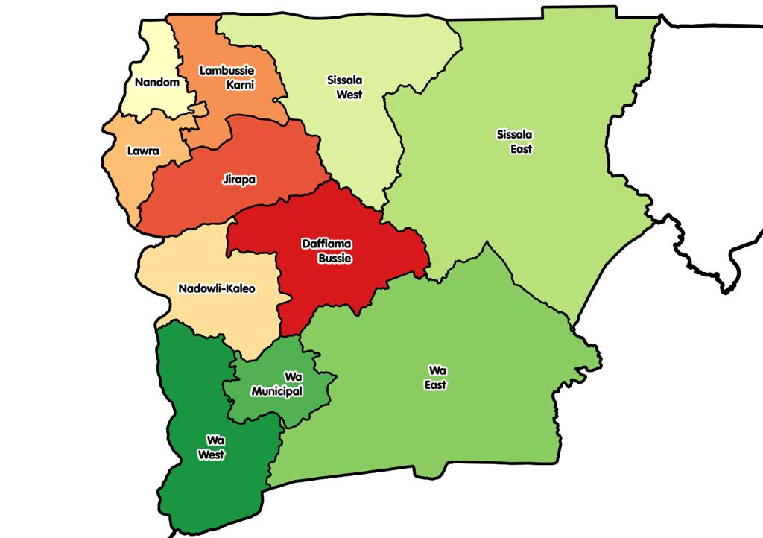

Compliment and catchment area of the hospital
It is a 188 bed capacity hospital and a referral institution (Level B). It serves as the Jirapa Municipal Hospital located in the North Western corner of the Upper West Region of Ghana. It lies between latitudes 10.52º North and longitudes -2.70º West. It covers a total land area of 1,188.6sq km. It is bordered to the South by the Nadowli District; to the North by the Lambussie-Karni district; to the West by Lawra District and to the East by the Sissala West District. Its location presents a special development advantage to the district. The Municipal has seven (7) Area Councils and one (1) Town council with a total of 170 communities. The hospital’s sphere of influence demonstrates the size or magnitude of its catchment area, the level, quality, range and intensity of services provided.
The hospital’s attendants or beneficiaries come from within and outside the Municipal, Region and Country. This is more so because of the quality health services rendered, its strategic location and the access to some specialist services.

Map of Jirapa District
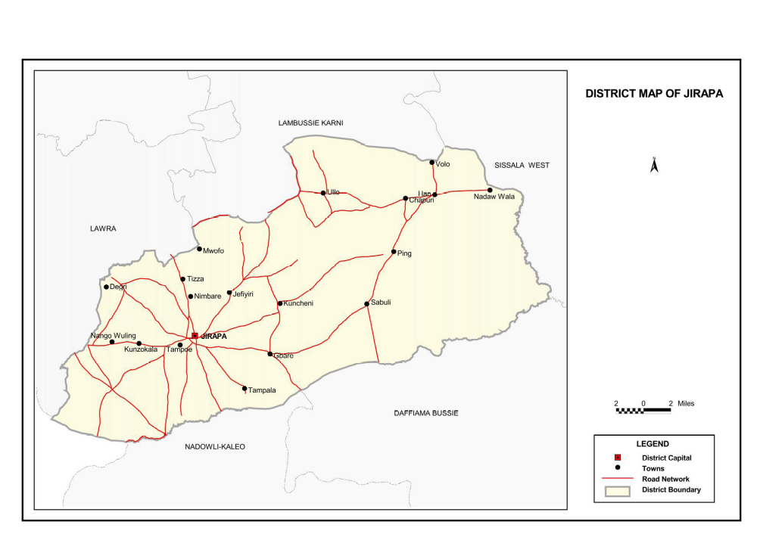

Rationale And motivation for A strategic development plan
The rationale and motivation for evolving a strategic development plan for the hospital can be explained in the statement: “where there is no vision, people perish” and “where there is a will, there is a way”.
Further on, we arrive at the following justification for the strategic plan. (Strategies; (1) improving Quality Health Care) (2) health care expansion) (3) harnessing spirituality)

CHAPTER TWO

Vision
(St. Joseph’s Hospital desires to ensure quality health care for all individuals).
Thus, to provide high quality health care in the most effective/efficient and innovative manner, specific to the needs of the communities we serve and at all times acknowledging the dignity of the patient reflecting the healing ministry of Christ”

Mission
St. Joseph’s hospital exists to provide affordable, high quality care in an effective and efficient manner in our catchment area and beyond.
It is therefore in partnership with all stakeholders while acknowledging the dignity of the patient or client.

Operationalization of Mission and Vision
To facilitate the translation of the mission and vision into concrete reality, a framework like this evolved from the mission and vision to programmes and from programmes to activities.

Services available

- Out-patient
- General Ward
- Surgery ward
- Male medical
- Female medical
- Dispensing
- Laboratory Services
- x-ray services
- ultrasound Scan
- Public Health Activities
- Nutrition and Rehabilitation Centre
- Mental Health Services
- Anti-retroviral Therapy
- Maternal and Child Health Services
- Neonatal Intensive Care (NICU)
- Eye care
- Dental care
- Chaplaincy
- Crèche.
- Physiotherapy
- Sick Bay services
- Wellness Clinic

BROAD POLICIES.
Relevant policies by Ministry of health that bring complete health to the patient are upheld in our institution and this runs through from 2023 to 2028.

Core values.
- Christ centeredness: To ensure that Christ is our role model in all endeavours.
- Team work: We wish to work together to achieve a common goal for together we stand divided we fall.
- Integrity: We work towards quality of possessing and steadfastly adhering to high moral principles or professional standards.
- Professionalism: We ensure that individual members are highly trained to acquire the skills, competence or character expected of them.
- Discipline: We recruit well trained professionals and monitor them to ensure acceptable patterns of behaviour.
- Client centeredness: The patient reigns supreme in our performance of our duties.
- Innovation: Every staff is poised to create ideas to ensure patient safety.

Existing Stakeholders

- Traditional leaders
- Politicians’
- Religious leaders
- Clients
- Staff
- Students
- Ghana education service
- MOH
- GHS
- Traditional birth attendants
- Opinion leaders
- Auditors
- Suppliers
- Banks
- NHIS
- Regulatory bodies
- CHAG
- NCHS
- Dioceses

Stakeholder Involvement
Stakeholders are people or organizations that invest/support the facility who are interested in results of the facility. Representing their needs and interests throughout the process is fundamental to good program evaluation. In collaborating with stakeholders the various processes will be followed:
- Identify stakeholders and review the list of key stakeholders needed in this strategic plan
- Identify the various activity implementation, advocacy, or funding/authorization decisions.
- Engage individual stakeholders and/or representatives of stakeholder organizations.
- Create a plan for stakeholder involvement and identify areas for stakeholder input.
Target selected stakeholders for regular participation in key steps, including supplying of equipment, support in infrastructural deficiencies, logistics etc

Stakeholder Analysis
No | Name | Interest | WHAT: (If not met) | Rank1-3mks
1. | Traditional leader | Quality Health care | Rioting | 2
2. | Politicians | Quality Health care | Advocate for removal | 3
3. | Staff | Better Condition of Service | Strike? Abysmal performance | 3
4. | Clients | Quality service | Complaints/Bad publicity | 3
5. | Traditional Healers | collaboration | complaints | 2
6. | Ghana Education Service | Quality Service & collaboration | Complaints/Bad reportage | 2
7. | Students | Quality Tuition & Mentoring | Rioting | 3
8. | Traditional birth Attendants | Collaboration | complaints | 2
9. | MOH | Policy compliance | Discipline | 3
10. | NGO | Health promotional issues | Boycott | 3
11. | Development Partners | Judicious use of resources | Boycott | 3
12. | Media | Health promotional issues | Negative reportage | 3
13. | Business men | Early payment | Complaint | 2
14. | Suppliers/ Pharmaceutical | Early payment | Boycott | 3
15. | Banks | Continue to do business with them. | Boycott | 3
16. | NHIS | Quality care | Withhold payment/surcharging | 3
17. | Opinion leaders | Quality Service | Rioting /Low patronage | 3
18. | Ghana Health Service | Adherence to polices | Discipline | 3
19. | Regulatory Bodies | Adherence to Statutory Regulations | Discipline | 3
20. | Auditors | Abiding by the statutory regulation | Negative reportage | 3

Swot Analysis
NO | AREA | STRENGTH | WEAKNESS | OPPORTUNITY | THREAT
1. | Human Resource | 1. Existence of competent managers. 2. Efficient recruitment processes.  3. Existence of in-service training.  4. Orientation for new staff.  5. Motivation for staff  6. Medical subsidy for staff | 1. Low level of management expertise for some managers.  2. Poor community linkages.  3.Inadequate  Critical staffs.  4. Staff demotivated for lack of office space.  5. Staff attrition.  6. Negative staff attitude.  7. Poor mgmt. of annual leave. | 1. Clinical meetings.  2. Staff durbars.  3. Staff devp’t training and retention of requisite ones.  4.Existence of training school | 1. Poaching by competitors.  2. Separation for marital reasons.  3. Not Accepting posting to the region.
2 | Infrastructure | Improved structures | Inadequate office space  Inadequate staff bungalows | Possibility of government and Donors awarding contracts | Inadequate funds to complete contracts on schedule.
3 | Logistics | 1. Availability of medical equipment.  2. Quarterly procurement for all units.  3. Acquisition of new vehicles | 1. Inability to render certain services, 2.Delay in paying suppliers leading to refusal of suppliers to supply creating shortages.  3. Poor maintenance culture. | 1. Availability of essential medicine list.  2. Presence pharmaceutical companies, chemical stores and periodic donations. 3.National Ambulance and other Ambulances from other clinics  3. Occasional donation of drugs and non-drugs consumables. | 1. Increased emergencies leading to increased mortalities.  2. Delay in reimbursement to acquire essential drugs endangering patient lives. 3. Elimination of certain essential medicine from the NHIS list.
4. | Collaboration | Respect earned from stakeholder | Irregular involvement of stakeholders in most of our decision making. | 1. Ability to seek health care delivery opinions from the opinion leaders.  2. Revamping of open day fora. | Mistrust from stakeholders
5. | Record keeping | 1. Well-structured record keeping procedure for staff and clients in place. | No safety measures against disasters | Possibility of getting qualified personnel posted to manage records. | Potential legal suits due to mismanagement of client records
6. | Specialist services | Ability to attract specialist visits (orthopedic, ophthalmic and other specialists) | Inadequate resources | 1. Well informed populace.  2. Improve institutional image.  3. Committed visiting specialist. | Delayed reimbursement by NHIS hinders performance leading to delay in paying specialists.
7. | Environmental sanitation | 1. Encouraging the environmental officer to intensify sanitary activities.  2. Intensified public education.  3. Ability to manage waiting time effectively.  4. Ability to keep the hospital clean. | The need for an additional incinerator for waste disposal. | 1. Use of the public address system.  2. Existence of the radio stations.  3.Environmental and sanitation department. 4.Existence of waste management company i.e. zoom lion | Possible outbreak of epidemic and breeding of reptile and dangerous animal

Key Issues.
- Human Resource
- Logistics
- Infrastructure
- Finance (NHIS) and out of pocket payment

Human Resource
STRATEGIC GOAL- Improve quality health care delivery in the hospital.
Strategic Objective 1
Recruit and train more critical staff to handle health related issues by 2028
Activities
- Lobby for staff through sponsorships, publicity and incentives.
- In-service training.
- Mandatory yearly appraisals
- Study leaves and promotions as merited

Strategic Objective 2
Increased capacity building programs.
Activities
- Safe care initiatives.
- Clock in/out.
Strategic Objective 3
Increased commitment and attitude of staff to all sick people.
Activity
- Study leaves and promotions are merited.
- Staff motivation.
- Staff medical subsidies
- Staff ID/name tags
- Complete staff files

Logistics
STRATEGIC GOAL- Availability of basic logistics for all departments.
Strategic Objective 1
Provision of required medical equipment.
Activities
- Strengthened procurement process
- Implement strong controls

Strategic Objective 2
To ensure the availability of ambulances are constantly in good condition for emergencies.
Activities
- Promote maintenance culture
- Implement strong control

Strategic Objective 3
Constant supply of non- drug consumables.
Activities
- Measures to reduce wastage.
- Ensure quarterly procurement practices are adhered to, to prevent shortage

Infrastructure
STRATEGIC GOAL- Improved hospital structures by the year 2028.
STRATEGIC OBJECTIVE 1
Construction/Renovation of mental ward and canteen.

Activities
- Allocate funding from IGF and from donor funds
- Write proposals for funding.
STRATEGIC OBJECTIVE 2
Improving of hospital appearance and structures by 2028.
Activities
- Painting of buildings.
- Re-wiring of hospital.
- Mortuary extension
- Recovery room at theatre creation
- NICU extension
- Incinerator creation
- Automatic change over for Generator
- Mental ward creation
- Cash pharmacy
- Canteen
- Theatre at maternity
STRATEGIC OBJECTIVE 3
Improve security by providing CCTV camera.
Activities
- Allocate IGF for constant work.
- Write proposals for funding.

Finance
STRATEGIC OBJECTIVE- Improved Revenue Mobilization to 95% by 2028
Activities
- Timely Submission of claims
- Incorporate claims and accounts billing into a paperless system (digital)
- Clock in/out system

CHAPTER THREE

Implementation Plan Human Resource
STRATEGIC GOAL - Improve holistic quality healthcare In The Hospital.
No | Strategic objectives | Activities | Person Responsible | Time | Objectively verifiable indicator (OVI)
1. | Recruit and train more critical staff to handle health related issues by 2028 | 1. Lobby for staff through sponsorships, publicity and incentives.  2. In-service training.  3.Mandatory yearly appraisals  4.Study leaves and promotions as merited | Core management | 2026 | List of short listed candidate with HR manager.
2. | Increased capacity building programs. | 1. Safe care initiatives.  2. Clock in/out. | QI team and Mgt | 2023  2023 to 2028 | QIT plan
3. | Increased commitment and attitude of staff. | 1. Study leaves and promotions are merited.  2. Staff motivation.  3.Staff medical subsidies  . | HR and Mgt. | 2026

Logistics

Strategic Goal- Availability Of Basic Logistics For All Departments.
No | Strategic Objective | Activities | Persons responsible | Time | OVI
1. | Provision of required medical equipment | 1.Strengthened procurement process  2.Implement strong controls | PO and Mgt. | 2023 to 2027 | Inventory at the Ward.
2. | To ensure the availability of an ambulance in the facility  - | 1.Promote maintenance culture  - Implement strong control | Management | 2023 to 2028 | Report with transport officer
3. | Constant supply of non- drug consumables. | 1. Measures to reduce wastage.  2.Ensure quarterly procurement practices are adhered to, to prevent shortage | Procurement officer and Store keeper | 2023 to 2028 | Plan with procurement officer.

Infrastructure
Strategic Goal- Improved hospital structures by the year 2022.
No | Strategic Objective | Activity | Person Responsible | Time | OVI
1. | Construction/Renovation of mental ward and canteen  Improving security by providing CCTV cameras | 1.Allocate funding from IGF and from donor funds  2.Write proposals for funding  2. Allocate IGF for constant work  2.1 Write proposal for funding | Core management | 2022 to 2025 | Proposal with Ag Estate Manager  Health service Administrator office
2. | Improving of hospital appearance and structures by 2028. | 1. Painting of buildings.  2. Re-wiring of hospital.  3.Mortuary extension  4.Recovery room at theatre creation  5.NICU extension  6.Incinerator creation  7.Automatic change over for Generator  8.Mental ward creation  9.Cash pharmacy  10.Canteen  11.Theatre at maternity | Ag Estate Manager | 2023 | Estimates with Estate manager

Finance
Strategic Goal- Improved Revenue Mobilization to 90% by the year 2020.
No | Strategic Objective | Activity | Person Responsible | Time | OVI
1. | Improved Revenue Mobilization to 95% by 2028 | 1.Timely Submission of claims  2.Incorporate claims and accounts billing into a paperless system (digital)  3.Clock in/out system | Accountant | 2022 to 2024 | Action Plan with Accountant
2. | Ensuring that all non-insured clients’ payment are captured appropriately. | 1 Sensitize the general public to demand GCR for all payment they make  1. Institute 24hour revenue collection. | Core management | 2014 | Pasted notice all over the facility.

CHAPTER FOUR

Organizational Structure
The organizational structure of the hospital is in tandem with the guidelines given by the National Catholic Health Services.

The Executive Board
The Executive Board, is the highest decision making body at the institutional level. It is the body that the Management Board reports to. It comprises the following persons:
1. A representative of the Bishop of the diocese
2. Institutional Management Team leader as an ex-officio member
4. Three other members appointed by the respective Bishop who has the competence in any of the health service management, financial management/accounting, or a health professional. The chairmanship of the board rests in the representative of the Bishop.
The Executive Board is responsible for the approval, supervision and monitoring of all activities of the institution that are beyond the hospital management. This covers the management, service as well as the financial activities of the institution. This board is expected to meet, at least, once every three months and review operations of the institution.

The Management Team
The Medical Superintendent, Health Service Administrator, The Nurse Administrator (DDNS/Matron) Pharmacist, head of Accounts, Chaplain, make up the core members of the Management Team. The team is headed by the medical superintendent who co-ordinates the activities of the other specialized areas.
He is the main communication channel through which information flows to the other key players in the organization.
The Health Service Administrator handles the health care support services (the day today activities of the hospital) and the head of nursing services is responsible for all nursing care in the Hospital.

SWOT ANALYSIS
Area | Strengths | Weaknesses | Opportunities | Threats
Management Issues | Core managers  Extended Managers(Various Departments) | Capacity of heads of units  Poor linkage/transfer of information | Clinical  meetings  Staff Durbars | Attrition of staff  Apathy
Human Resource | Improved recruitment processes  Improve incentive system | Inadequate Human Resource(Critical areas) | Self-development  Training and retention of requisite staff | Separations(e.g Marital Issues, Death etc)  Regional needs
Infrastructure | Improved structures  Improve appearance of structures | Staff De-motivated due to lack of office space  Lacked of special service to clients | Likely to see improvement with the award of contracts by gov’t/Donors and the hospital | Lack of funds to complete these projects on time
Equipment | Some equipment received to supplement or replace old and outdated ones  Digital x-ray  Cardiotocogram  Patient monitors  ECG  3-part hematology analyser  Bilirubin meter  Chemistry analyser (open system)  Theatre lamp | Unable to render certain services due to the lack of requisite equipment | Have the manpower to man these equipment  Improved hospital status | Idle staff may be tempted to move to places where they can get these equipment to practice their trade
Collaboration | Respect earned from stakeholders  Regular family health meetings  Regular engagement of stakeholders | Poor involvement of stakeholders in most of our decision-making | Seek their opinions on health service delivery  Revamp Open Day Forum | Poor collaboration may not enhance co-operation and can lead to mistrust
Record Keeping | A well - structured Record keeping policy for staff and clients is in place | Safeguarding these records against disasters  Misfiling of patient folders | Training of more staff on Record Keeping  Appoint qualified personnel to manage these records | Mismanagement of clients Records can lead to legal battles
Logistics and Medicines | Strengthening of procurement process  Reduction of waste  Implementation of strong control system  Promote maintenance culture  Occasional Donation of medicine and non-Drugs to support service delivery | Delay in payment by NHIA leading to delay in payment of suppliers which result in refusal to supply Medicines and other logistics which causes shortages in the system | Availability of essential medicines list from MoH  Local Pharmaceutical Co’s  Local Chemical stores  Periodic Donation | Lack of some essential medicines can endanger patients’ lives  Delay in Reimbursement by NHIS to settle Creditors  Elimination of certain medicines from the NHIS medicines list  Unskilled personnel
Specialist Services | Visits to the facility by orthopaedics, urologists and other specialists | Lack of infrastructures  Inadequate equipment Inadequate resources | The populace is sensitized  Commitment of visiting specialist  Improve image of the institution | Delay in payment by NHIS  Lack of equipment can hinder operations  Institutional workload and space during these visits
Capacity Building | Existing in-service training plan for staff  Orientation of new staff | Staff attrition  Negative staff attitude  Poor management of study leave | Existence of health training institution | Non-compliance of study leave policy
Transportation | Acquired a vehicle from the IGF  Implement vehicle maintenance policy | Unmotorable Ambulance | National Ambulance Service in Jirapa  Other Ambulances from other clinics in neighbouring districts | Delayed emergencies can increase mortality Poor maintenance leads to the early deterioration of these vehicles
Environment and sanitation Management | Greening all year round  Improve waste management (segregation and IPC)  Improve management of orderlies  Client education (public address system) | Need for an additional incinerator for waste disposal  Inability to control animals | Use of the public address system, presence of an environmental officer,  Existence of radio stations  Presence of private waste management company (e.g. Zoomlion) | Unclean surroundings can worsen patients conditions  Crawling animals like snakes, scorpions and others can breed and pose a threat to patients, staffs and relatives

Functions of the Management Team Members
1. Each member of the core management team is responsible for the effective and efficient implementation of the activities within their primary areas of professional competence.
2. The team leader is responsible for
-coordination of management activities
-ensuring that all management team members work together to ensure that the objectives of the institution are achieved
-ensuring report and other required documentation are prepared and available on time
-signing all relevant documentation of a general nature in the name of the institutions where uncertainty exists to who is to sign.

Decision Making by the Management Team
Decision making is by consensus. Due cognizance of professional knowledge and skill must be acknowledged by contributing members of the team. At all times it is important to ensure that all issues are understood by all effectively for implementation to commence.
Decision taken by the management team becomes the collective responsibility of all team members.

Core Management Team Members
Management team members are recognized by their professional qualification and competence as well as the job description may carry. Appointment as the medical officer-in-charge, the matron or the health service administrator can only be made if the individual has the requisite professional qualification for that position.

Core Management Team Members
- Medical Superintendent - Chairman
- Health Service Administrator (DCHSA)
- Nursing Administrator (DDNS)
- Head of Finance (Accountant)
- Chaplain
- Pharmacist in-charge

CHAPTER SIX

Framework From Programmes To Activities, 2023-2028
PROGRAMME | OBJECTIVES | ACTIVITIES | RESPONSIBILITY | INDICATORS | MEANS OF VERIFICATION
Renewal of accreditation | To update service providers’ state, status and capacity for service delivery and impact | Meetings  Advisory board  Core management  Extended “  Departmental  Clinical  Workshops (staff and management)  Data collection, collation and management  Visit of accreditation team | Core management | No. of meetings held.  No. of visits. | Report  Report
Strategic plan management | To operationalize systematically and efficiently the implementation of the plan  To monitor and evaluate the plan implementation process/stages | Meetings and site visits:  -units/departments  -core management  -extended “  -advisory board  -Workshops | Core management | No. of meetings/site visits  No. of workshops | Reports  Reports
Human resource/personnel development and management | To ensure right staff mix at all times  To motivate and update management and staff  To reduce staff attrition/turnover | Upgrading courses/training: short to long-term (local and foreign)  Workshops and seminars.  Motivational packages  -annual awards  -staff accommodation  - medical subsidies  -transport, etc.  -welfare fund/scheme  Conferences: | Human resource manager  Core management | No. of staff on course and/or upgraded  No. of workshops or seminars attended  Motivational budget  No. of conference exposures | Staff development plan.  Reports or interview.  Expenditure on motivational packages  staff appraisal
Public health education/ campaigns | -To disseminate health messages/information to the communities  -To promote and sustain maternal/child health services in the communities  -To encourage preventive health care delivery  -To reduce the cost of curative health services | -Organize durbars/meetings (quarterly and monthly)  -Home visits  - radio discussions  -Defaulter tracing  -Improving documentation (database)  -School health  -Testing and Counselling services  -Family planning services  -Active surveillance | Public health nurse/community health nurse  (Hospital) | -No. of durbars organized annually  -No. of meetings organized per annum  -No. of home visits made | -Minutes  -Reports  -Data base  -Monthly Report/DHIMS
Collaborative partnerships, etc. | -To promote cross fertilization of ideas, technologies, practices, etc.  -To expand resources base: funding, equipment, machinery, transport, etc.  -To promote innovative and sustainable institutional management  - To facilitate family health meetings | -Networking  -Lobbying  -Advocacy  -Proposal writing  -Stakeholder meetings | -Advisory Board and Health Services Administrator  -Medical superintendent | -No. of institutional partners registered  -No of proposals  -No. of exchange programmes/visits per annum  -Inflow of support (gifts, donations, etc.)  -No of stakeholder meetings | -Partnership correspondence file  -Programmes/ projects in progress  -Visitors’ book signed  -Proposal file  -minutes
Infrastructural, transport, machinery and equipment improvement and development | -To provide a right mix of logistic support  -To enhance working environment and conditions  -To motivate management and staff | -Improving maintenance culture  -Stock taking/inventory  -Auditing  -Development of an operations and management plan  -Proposal writing  -Training and capacity development | -Maintenance/ procurement committees  -Core management | Inventory of property  Maintenance regime  Audit/management reporting | Minutes  Reports  Observation/ inspection
Institutional/ organizational capacity building | To institute proper management on capacity building  To provide an organizational framework  Promote a functional environment (structures, systems, etc. in place) | Training and capacity building for functional structures, systems, etc.  Logistic support of the above  Monitoring and evaluation of the above | Diocesan Health Secretariat  Advisory Board  Management and Quality Improvement Team | Strategic plan / management  Human resource plan  No. of meetings / fora held | Reports (management, committees, etc.)
Environment and Sanitation management | To promote sanitation and hygiene  To institute management of environment and sanitation regime  To improve security and sanity of the hospital | Public health education  Training and motivating security personnel  Environmental cleanliness and protection  Developing land use plan and management  Logistic support  Provision of transport and equipment | Public health unit  Environment and sanitation committee  HSA /personnel officer | No. of trained and equipped security  Extent of logistic support  Inventory | Observation /inspection  Interviewing  Documentation
Resource mobilization and management | To promote financial sustainability and management  To ensure a good institutional resource base  To encourage community participation  To partner effectively with stakeholders | Training and capacity building  Maintenance of human resource base  Evolving structures and systems of mobilization and management  Developing a human resource plan | HSA /personnel officer  Advisory board  Core management | Update Human Resource plan in use  Financial mobilization and management structures and systems in place  Institutional budgets made  Financial strength of the institution | Copy of Human Resource plan  Institutional budgets  Management reports  Annual audit reports
Health data base and management of information systems | To Strengthen the available data base  To facilitate data generation, management and use  To promote sound planning | Training and capacity building  Data collection and collation procedures  Sustain Computerization and networking  Procurement of office equipment and logistics | Training and capacity building  Data collection and collation procedures  Procurement of office equipment and logistics | capacity building fora  updated management information system in use  No of equipment and logistics  Timely reporting in a year | Reports  Validated Data  Computerized system  Evidence of backup (hard and soft copies)
Laboratory Diagnostic service | To increase the number of BMS from 2 to 4 and T.Os from 1 to 10  To equip the lab adequately for quality diagnostic services  To ensure adequate stocking of blood banks for emergency preparedness to avoid deaths due to blood shortage | Lobby the region for posting  Engage personnel who have completed school for casuals  Procure chemistry haematology analyser  Organize at least two blood donating exercise in every quarter | Lab manager | Number of lab staff increased to run 24hrs services  Availability of chemistry and haematology analyser  Availability of blood banks fridge | Reports

Budget of Activities
NO | STRATEGIC OBJECTIVE |  | ACTIVITIES |  | START DATE |  |  | FINISH DATE | PERSON RESP |  | CORE ELEMENTS (COST). GHc | REMARKS
1. | Adaption of paperless system |  | 1.0 Sensitizing 300 staff.  1.1 training about 110 key respondents. |  | September 2023 |  |  | March 2024 | IT manager/mgt. |  | 52,000.00
Sub-Total |  |  |  |  |  |  |  |  |  |  | 52,000.00
2. | Ensuring that all non-insured clients’ payment captured appropriately. |  | 1.0 Sensitize staff to enhance proper documentation  1.2 Engaging on-site banking |  | May, 2022 |  |  | 2023 | Accountant |  | 0.00  5000.00
Sub-Total |  |  |  |  |  |  |  |  |  |  | 5000.00
3. | Making Renovation of Offices and staff bungalows |  | 1.0 Amending of roofing (zinc, kneels, and plywood)  1.10 Cuba’s doctor bungalow  1.20 bungalow 6  1.30 Isolation Center (covid-19)  1.40. quarters 13A  1.50 Constructing mental ward  1.51 construction of canteen |  | December 2022  September 2021  November 2021  September 2021  June 2022  June 2022 |  |  | December 2023  September 2022  December 2022  2022  October 2022 | management |  | 4000.00  200,000.00  4,000.00  30,000.00  5,000.00  104,000.00  10,800.00
4. | Increased capacity building programs |  | 1.0 Send eight (10) RGN to each specialized training school.  Two (2) to pediatrics  Two (2) to ophthalmic  Two (2) to peri-operative nursing  Two (2) to incentive care nursing  Two (2) to medical school  1.1 In service training sessions organized for 40 staff quarterly.  1.2 continuous professional developments. |  | June 2020  December 2023 |  |  | 2025  2027 | Management  DDNS |  | 9000.00  9000.00  10,000.00  6000.00  200,000.00  6,000.00  70,000.00
5. | Increased commitment and attitude of staff. |  | 1.0 draw succession plan for Study leave to staff merited.  1.10 Staff motivation by given medical subsidies  1.11 staff name tags |  | January 2022 |  |  | 2023 | Administrator |  | 0.00  14,000.00  13,000.00
6. | Construction of a canteen for the facility |  | 1.0 putting up a building (construction)  1.1 roofing  1.2 painting |  | June 2022 |  |  | December 2023 | management |  | 10,800.00  6000.00  15,000.00
7. | Ensure Constant supply of drugs and non- drug consumables. |  | 1.0 Institute constant tally card monitoring for pharmacy and stores.  1.1 Ensure quarterly procurement control system  1.2 strengthening of procurement process  1.2 Allocate IGF for the purchasing of the equipment  1.3. chemistry analyzer  1.4. hematology analyzer  1.5 blood bank fridge  Total |  | January 2023  July 2017 |  |  | 2028  2019 | Procurement committee  Procurement committee |  | 4500.00  0.00  30,000.00  30,000.00  5,000.00  65,000.00
8. | Procure chemistry, hematology analyzer and blood bank fridge
9. | Strengthening of the security system |  | 1. Allocate funding from IGF  1.1 installing of CCTV Camera |  | June 2021 |  |  | 2028 | Management  administrator |  | 19,400.00  0.00
10. | Complete the Renovation of the maintenance unit to mental ward |  | 1.0 Acquire estimates for the renovation.  1.1 ceiling  1.2 pallets  1.1 Solicit District Assembly, Diocese or Donors for support |  | June 2022 |  |  | 2014 | management |  | 104,000.00  0.00
11. | Construct a car parking garage to arrange all vehicles into it. |  | Allocate IGF for the construction.  1.0 roofing for the car garage  1.1 roofing for motor garage for clients relatives. |  | 2023 |  |  | 2028 | management |  | 15000.00  10000.00
12. | Construct a pave at Mortuary to the gate. |  | Allocate IGF for amending  1.0 need for stones  1.1 need for gravels |  | 2023 |  |  | 2024 | management |  | 2,000.00  80,000.00  36,000.00
13. | Purchasing of motor king and Pick-up |  | Allocate IGF for it. | 2023 |  |  | 2027 |  | Procurement committee |  | 800,000.00
14. | Construct a cash pharmacy | Allocate IGF for the construction  1.1 Painting |  |  | September 2022 | September 2023 |  |  |  | management | 40,000.00
15. | Increase employment for laboratory staff and other critical areas | 1.0 lobby the region for posting  1.1 Engage three (3) personnel who have completed school as casuals |  |  | July 2022 | 2024 |  |  |  | Lab manager  Accountant | 0.00  200,000.00
15. | To ensure adequate stocking of blood banks | 1.0 Organize at least two blood donating exercise in every quarter. |  |  | July 2023 | continuous |  |  |  | Lab manager | 20,000.00

CHAPTER SEVEN

Staff Strength
Below is the breakdown of staff strength both critical and supporting.
GRADES | AT POST | NUMBER NEEDED | SHORTFALL
General Practitioner (MO) | 5 | 6 | 1
Specialist (O&G) | 1 | 3 | 2
Specialist (Orthopaedic) | 0 | 1 | 1
Midwives | 46 | 50 | 2
Deputy Director of Nursing Services | 2 | 2 | 0
Physician Assistants(Clinicians) | 4 | 8 | 4
Physician Assistant(Anaesthesia) | 3 | 4 | 1
Physician Assistant (Dental) | 1 | 2 | 1
Physiotherapist Assistant | 2 | 2 | 0
Biomedical Scientist | 2 | 2 | 0
Technical Officer (Lab) | 1 | 1 | 19
Laboratory Assistant | 4 | 8 | 4
Blood Donor Organizer | 0 | 2 | 2
Pharmacist | 1 | 1 | 0
Pharmacy Technician | 3 | 3 | 0
Dispensary Assistant | 2 | 5 | 3
Radiographer | 1 | 2 | 1
Radiographer Assistant (Technical Off.) | 0 | 2 | 2
Radiographer Attendant | 0 | 2 | 2
Enrolled Nurses | 38 | 53 | 0
Health Aid/Ward Assistants | 4 | 10 | 0
Registered General Nurses | 56 | 39 | 0
Physiotherapist | 0 | 1 | 1
Peri-Operative Nurse | 1 | 2 | 1
Ophthalmic Nurse | 2 | 2 | 0
ENT Nurse | 3 | 2 | 1
Critical Care Nurse | 0 | 2 | 1
Community Health Nurse | 7 | 7 | 0
Public Health Nurse | 2 | 2 | 1
Psychiatry Nurse | 45 | 1 | 0
Disease Control Officer | 1 | 1 | 0
Biostatistician | 1 | 2 | 1
Health Information Officer | 1 | 2 | 1
Medical Record Officers | 4 | 10 | 6
Mortuary Attendant | 2 | 3 | 1
Sterilization Machine Operator | 2 | 2 | 0
Administration Staff | 2 | 2 | 0
Accounts Staff | 8 | 8 | 0
Drivers | 2 | 3 | 2
Security Officers | 7 | 5 | 2
Orderlies | 30 | 11 | 0
Artisans | 5 | 5 | 0
Clinical Engineering Manager | 1 | 1 | 0
Transport Officer | 0 | 1 | 1
Supply Officer | 1 | 1 | 0
Estate Officer | 0 | 1 | 1
Catering Officer | 0 | 1 | 1
Leading Launderer | 0 | 2 | 2
Total | 268 | 288 | 36

Hospital Bed Occupancy
St. Joseph’s Hospital has a bed capacity of 188. The breakdown is as follows;
- General Ward i.e. Male and Female = 20
- Surgical Ward i.e. Male and Female = 20
- Male Medical Ward = 20
- Female Medical Ward = 20
- Children ward = 45
- Maternity Ward = 33
- Neonatal Intensive Care Unit (NICU) = 12
- Religious Ward = 8
- Emergency Ward =10

